RAY-VASC: A Multidomain N-of-1 and Small-Series Protocol for Complex Neurovascular Disease
Logan Henderson
Independent Researcher, Houston, Texas, United States
Correspondence: Logan Henderson

Abstract
Background: Complex neurovascular and mixed neurodegenerative-vascular phenotypes rarely present as single-pathway conditions. Progressive supranuclear palsy-spectrum syndromes, vascular cognitive impairment, vascular Parkinsonism, post-stroke cognitive or Parkinsonian syndromes, traumatic brain injury burden, sleep disruption, respiratory limitation, metabolic instability, mood burden, dysphagia, functional dependence, fall risk, and caregiver instability can interact as one coupled biological and operational system. Conventional low-frequency clinical follow-up is often too coarse to detect within-person fluctuations, confounder periods, adherence effects, and short-term directional signal.
Objectives: The primary objective is to determine whether a burden-limited, caregiver-supported, 12-month longitudinal N-of-1 protocol can produce feasible, interpretable data during an initial 90-day window and across a 52-week observation period. Secondary objectives are to estimate within-person directional signal in cognition, mobility/falls, mood/distress, sleep/repair, respiratory burden, dysphagia, circadian regularity, caregiver burden, and modified ADL/IADL function. Exploratory objectives include serial EEG trajectory analysis, biomarker-EEG synchronization, wearable feasibility, APPRE response-policy stability, and small-series aggregation readiness.
Methods: RAY-VASC is a prospective longitudinal observational N-of-1 protocol with a small-series expansion pathway. It is structured as a two-cycle Compounding Plasticity Architecture with three phases per cycle: Phase 1 Baseline/Pre-Load, optional Phase 2 Governed Plasticity Window, and Phase 3 Sustain/Integration. EEG is a Tier 2 Required measure across all protocol phases when a Tier 2 implementation is declared. Twelve scheduled EEG sessions (EEG-01 through EEG-12) span both 26-week cycles and capture resting-state spectral power and P300 event-related potential trajectories as primary neuroplasticity readouts. EEG sessions are co-scheduled with biomarker draws within a 72-hour window at quarterly assessment timepoints.
Setting and participants: The protocol may be implemented in home-based, clinic-based, assisted-living, memory-care, rehabilitation, outpatient, or hybrid settings if the minimum site capability is met. Eligible participants are adults aged 50 years or older with confirmed or probable PSP-spectrum disorder, vascular cognitive impairment or vascular dementia, vascular Parkinsonism, post-stroke cognitive or Parkinsonian syndrome, or a mixed neurodegenerative-cerebrovascular phenotype.
Ethics and dissemination: External implementation requires local ethics review, IRB review, or formal determination as applicable. OSF registration is required before external prospective subject data collection. Public data sharing is limited to de-identified protocols, forms, schemas, synthetic datasets, analysis notebooks, and evidence maps unless separate consent and privacy review authorize additional sharing.
Keywords: RAY-VASC; N-of-1; complex neurovascular disease; vascular cognitive impairment; progressive supranuclear palsy; vascular Parkinsonism; APPRE; Regenerative Loop; EEG; qEEG; P300; p-tau217; patient-reported outcomes; open science; SPIRIT; SPENT.

1. Introduction
Complex neurovascular disease is not operationally simple. A participant with vascular cognitive impairment, PSP-spectrum features, post-stroke injury, sleep fragmentation, respiratory disease, dysphagia, mood symptoms, falls, polypharmacy, caregiver burden, and recurrent acute illness events does not live inside separate diagnostic compartments. Cognition changes with sleep. Gait changes with fatigue, oxygenation, medication timing, fear of falling, and recent injury. Mood changes with isolation, sleep debt, breathing burden, and functional loss. Swallowing safety changes oral-input adherence, aspiration risk, and hospitalization risk. A protocol that treats these domains as independent risks, confusing signal with noise, and missing the operational causes of decline.
RAY-VASC was built to address that operational gap. The core research question is not whether any single intervention cures neurovascular disease. The core question is whether structured, repeated, multidomain measurement can detect interpretable within-person trajectories in complex phenotypes where standard randomized trial designs may be premature or too coarse. The parent framework, The Brain That Remains, defined the residual-capacity hypothesis: substantial structural disease may coexist with state-dependent functional variation that is measurable, reproducible, and not simply noise. That hypothesis does not claim that lost tissue is restored. It proposes that remaining networks may express meaningfully different levels of function under different physiological, behavioral, and environmental conditions.
The RAY-VASC protocol translates the residual-capacity hypothesis into an externally implementable design by combining a prospective longitudinal N-of-1 and small-series measurement spine, a two-cycle three-phase temporal architecture, and APPRE, the Algorithmic Personalization Predictive Response Engine. In this protocol, APPRE is not a validated artificial intelligence or clinical decision support. It is a transparent schema-and-rules framework for data integrity, confounder annotation, and versioned response-policy updates.
Multidomain prevention research provides methodological precedent. The FINGER trial demonstrated that bundled multidomain lifestyle intervention could be structured and measured in at-risk older adults (Ngandu et al., 2015). World-Wide FINGERS extended the multidomain dementia-prevention concept across settings (Rosenberg et al., 2020). These studies do not prove RAY-VASC. They justify the methodological premise that cognition, function, vascular risk, activity, sleep, mood, and social/caregiver environment are appropriate to study together. The RAY-VASC contribution is narrower and operational: a measurement protocol that can be preregistered, audited, replicated, and improved over time.

2. Objectives and hypotheses
The primary objective is to determine whether the RAY-VASC Tier 1 protocol is feasible and produces interpretable longitudinal data over the first 90 days in adults with complex neurovascular or mixed neurodegenerative-vascular phenotypes. Feasibility is operationalized as daily log completion proportion, weekly packet completion proportion, caregiver/proxy completion rate, 90-day retention, interpretable-cycle proportion, adverse-event documentation completeness, confounder annotation completeness, and participant/caregiver burden acceptability.
Secondary objectives are to estimate within-person directional signal in cognition, functional mobility and falls, mood/distress, sleep/repair, respiratory burden, dysphagia, caregiver burden, circadian regularity, and modified ADL/IADL function using pre-specified measurement windows and signal thresholds. The protocol also evaluates adherence rates, missingness patterns, caregiver-supported completion, confounder density, and APPRE response-policy auditability.
Exploratory objectives include serial EEG trajectory analysis, biomarker-EEG synchronization, wearable feasibility, lagged cross-domain analysis, and the feasibility of aggregating multiple N-of-1 trajectories into a small-series evidence base without erasing individual heterogeneity.
Pre-specified exploratory lagged hypotheses are:
- Sleep-to-cognition/motor lag hypothesis: sleep quality over lag 0-2 days predicts next-day cognitive clarity score and TUG performance within interpretable measurement windows.
- Exertion-to-mood lag hypothesis: exertion dose in activity minutes over lag 0-7 days predicts subsequent weekly mood/distress trajectory.
- Inflammation-to-EEG synchrony hypothesis: hs-CRP and IL-6 at quarterly co-scheduled draws correlate with EEG slow-wave power at the matched EEG session within a 72-hour window.
The primary feasibility hypothesis is that a structured, caregiver-supported, burden-limited RAY-VASC Tier 1 protocol can achieve at least 70% daily log completion and at least 70% weekly packet completion over the first 90 days. The directional-signal hypothesis is that within-person change of at least 0.3 standard deviations from baseline, sustained across at least two consecutive interpretable cycles in at least two pre-specified domains, may indicate a candidate signal warranting further study. This threshold is a signal-detection heuristic only. It is not a validated clinical responder criterion and does not establish efficacy or disease modification.
Figure 5 converts the primary feasibility endpoint set into a dashboard schema that can be reproduced in spreadsheets, REDCap, ePRO exports, or analysis notebooks.
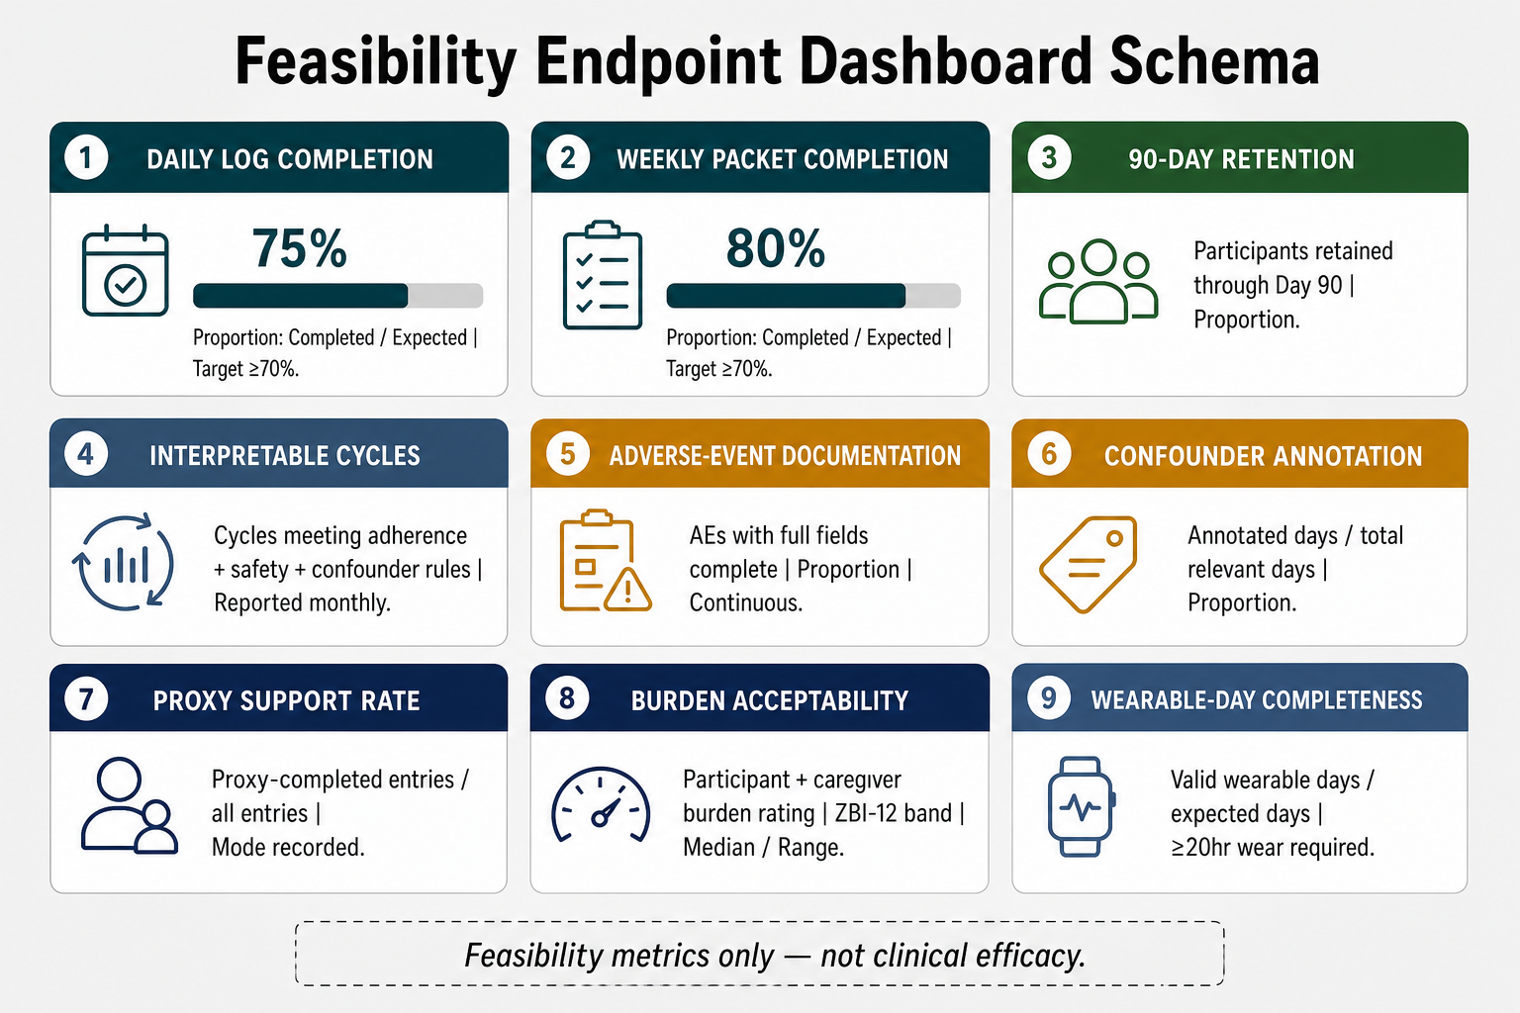
Figure 5. Feasibility Endpoint Dashboard Schema. Dashboard schema summarizing completion, retention, interpretable-cycle, adverse-event, confounder, proxy-support, burden, and wearable-day metrics. These are feasibility metrics only and are not clinical efficacy endpoints.
There is no formal between-group comparator in the current observational N-of-1 implementation. Each participant serves as their own internal reference, with baseline variability estimated during pre-specified baseline windows. Future protocol versions may add randomized legal-input sequences, crossover blocks, sham controls, or usual-care comparison arms when feasibility, standardization, and governance justify that step.

3. Study design and reporting standards
RAY-VASC is a 52-week prospective longitudinal observational N-of-1 protocol with a small-series expansion pathway. It is not a randomized, blinded crossover efficacy trial. The term N-of-1 is used here to denote prospective within-person repeated measurement with baseline variance estimation, cycle interpretability rules, confounder annotation, and individualized response-policy updates. If implemented across multiple participants, RAY-VASC becomes a small-series protocol consisting of parallel individual N-of-1 trajectories.
RAY-VASC is structured as a Compounding Plasticity Architecture: a two-cycle, three-phase design in which each phase serves a distinct mechanistic role and each cycle builds on the neurotrophic substrate established by the preceding one. Phase 1 (Pre-Load) establishes baseline variance, initiates legal neurotrophic inputs where clinically appropriate, and compounds the biological substrate hypothesized to support neuroplasticity. Phase 2 (Governed Plasticity Window), where separately activated under lawful, clinician-governed, ethics-approved conditions, is the mechanism-release window in which neuroplastic reorganization is hypothesized to occur within a prepared and loaded network environment. Phase 3 (Sustain/Integration) tracks durability, drift, safety, and consolidation. Cycle 2 restarts Phase 1 at a new within-person baseline and tests whether Cycle 1 findings can be replicated or refined.
This architecture is hypothesis-generating. RAY-VASC does not claim that the Compounding Plasticity Architecture repairs, reverses, or modifies neurovascular disease. Those claims require powered controlled trials with pre-specified primary endpoints. The present protocol is designed to establish feasibility, signal-detection thresholds, measurement reliability, and the conditions under which future efficacy trials can be responsibly designed.
The protocol is structured against SPIRIT 2025, SPENT 2019 for N-of-1 protocols, SPIRIT-PRO for patient-reported and proxy-reported outcomes, CONSORT 2025 and CONSORT-CENT for downstream results reporting, TIDieR-style exposure documentation, and open-science standards for registration, version control, protocol availability, and analysis reproducibility.
Table 1. Three-phase RAY-VASC architecture.
Phase | Window | Primary purpose | Governance boundary
Phase 1: Baseline / Pre-Load | Cycle 1 Weeks 0-4; Cycle 2 Weeks 27-30; minimum 14 clean days per baseline window | Estimate baseline variance, test data capture, document usual care, legal inputs if present, Regenerative Loop adherence, safety, and confounders. | Observational; usual clinical care remains clinician-directed. Legal inputs are documented, not recommended.
Phase 2: Governed Plasticity Window | Optional; Cycle 1 nominal Weeks 5-16; Cycle 2 nominal Weeks 31-42 | Document governed exposure context, acute/subacute outcomes, safety events, EEG/biomarker trajectory, and confounders where lawful governance exists. | Optional only. Controlled-substance exposure is clinician-governed, ethics-approved, as-administered, and never APPRE-tuned.
Phase 3: Sustain / Integration | Cycle 1 Weeks 17-26; Cycle 2 Weeks 43-52 | Track durability, drift, adherence, adverse events, caregiver burden, response-policy stability, EEG durability, and biomarker synchrony. | Observational; no efficacy claims. Phase 2 non-activation does not invalidate the protocol.
Table 2. Phase transition and termination criteria.
Transition | Required criteria
Phase 1 -> Phase 2, if activated | >=14 clean interpretable days; >=70% daily Tier 1 completion; no active Grade 3+ adverse event; OSF preregistration confirmed; ethics/IRB determination or formal determination in writing; baseline EEG completed; independent clinician-governed program clears participant.
Phase 1 -> Phase 3, if Phase 2 not activated | >=14 clean interpretable days; >=70% daily Tier 1 completion; no active severe adverse event; clinician review complete; APPRE baseline response policy locked.
Phase 2 -> Phase 3 | Phase 2 governance program closed; >=4-week post-last-exposure integration period elapsed; no active severe adverse event; exit EEG session completed where EEG track active; clinician clearance for Phase 3.
Phase 3 Cycle 1 -> Phase 1 Cycle 2 | >=8-week sustain/integration observation window complete; Cycle 1 feasibility summary generated; APPRE response policy updated; caregiver burden sustainable or mitigation plan active; participant/LAR consents to Cycle 2; clinician safety-log review complete.
Protocol termination | Participant withdrawal; clinician-directed suspension; caregiver system collapse without replacement; Tier 1 completion <50% over any 4-week window with no recovery plan; serious adverse event requiring protocol-level reassessment.
The RAY-VASC framework originated from the clinical complexity of an individual with PSP-spectrum disorder, vascular cognitive impairment, vascular Parkinsonism, sleep disruption, respiratory burden, and caregiver dependence. Caregiver feasibility, proxy completion, burden ceilings, privacy protections, and Phase 2 governance safeguards were shaped by the operational constraints encountered in that originating context. Future external implementations should convene patient and caregiver reviewers before enrollment to review Tier 1 burden, proxy-report workflows, safety triggers, and dissemination language.

4. Study setting and site eligibility
RAY-VASC may be implemented in private homes, family-supported homes, assisted-living, memory-care, rehabilitation, outpatient neurology, geriatrics, sleep-medicine, academic medical center, community clinic, or hybrid home/clinic settings. The protocol is not restricted to academic medical centers because the target population often exists outside ideal research environments.
A site must meet minimum capability before enrollment. External implementation without Logan Henderson present is a design requirement. The repository materials must therefore include the protocol, forms, data dictionary, APPRE schema, adverse-event log, confounder log, stack/legal input log, fall event form, and analysis conventions.
Table 3. Minimum site capability for implementation.
Capability | Minimum requirement
Clinical oversight | Identified physician, advanced practice clinician, or site clinician responsible for safety escalation and medication review.
Consent workflow | Capacity assessment, consent/assent process, and legally authorized representative or proxy pathway, where applicable.
Medication and interaction review | Baseline reconciliation of prescription, over-the-counter, nutraceutical, sleep, pulmonary, neurologic, psychiatric, and cardiovascular agents.
Safety escalation | Written adverse-event escalation plan, emergency contact chain, urgent-care triggers, and after-hours escalation method.
Data capture | Paper forms, secure spreadsheet, REDCap, ePRO, or custom schema implementation with export capability.
Privacy and security | De-identification rules, access control, secure storage, publication review, and prohibition on public raw clinical documents.
Caregiver/proxy support | Identified a caregiver or proxy available for daily and weekly capture where self-report is unreliable.
Caregiver/proxy training | Training on Tier 1 forms, fall/near-fall definition, breathlessness and sleep anchors, mood/distress anchors, adverse-event triggers, and mode-shift logging.
Burden monitoring | Process to reduce measurement burden if participant or caregiver capacity declines.
Protocol fidelity | Schedule-of-events adherence, deviation log, APPRE response-policy update process, and missingness documentation.
Amendment tracking | Version-controlled protocol, forms, schemas, analysis plan, repository tag, and OSF update pathway.

5. Participant eligibility
The target population is adults aged 50 years or older with complex neurovascular or mixed neurodegenerative-vascular phenotypes where standard single-domain measurement is inadequate. Eligibility is organized into diagnostic, functional/safety, consent/capacity, and optional Phase 2 governance gates.
Table 4. Core eligibility framework.
Domain | Inclusion criteria | Exclusion criteria
Diagnostic phenotype | At least one of: confirmed/probable PSP-spectrum disorder; vascular cognitive impairment or vascular dementia; vascular Parkinsonism; post-stroke cognitive or Parkinsonian syndrome; mixed neurodegenerative-cerebrovascular phenotype with documented clinical rationale. | No qualifying diagnostic category or insufficient documentation to classify phenotype.
Functional and clinical stability | Age >=50 years; stable medical regimen for approximately 8 weeks where feasible; no recent hospitalization; ability to complete Tier 1 measurement directly or through proxy; caregiver/support person available at least 5 days/week if self-report is unreliable. | Unstable cardiopulmonary status; active acute infection or unstable illness; acute stroke/TIA/seizure or major neurological event within 12 weeks; severe hepatic/renal impairment judged unsafe; very high falls risk without mitigation; severe dysphagia without nutrition/administration plan.
Consent and participation capacity | Written informed consent, or assent plus legally authorized representative/proxy consent where decisional capacity is impaired; local clinician identified for adverse-event escalation and medication review. | No feasible consent/LAR pathway; no feasible daily data-capture pathway; concurrent trial where interference cannot be documented and managed.
Optional Phase 2 governance | Only if separately planned: a clinician-governed program applies its own psychiatric, cardiovascular, medication, and regulatory screening. | Any Phase 2 contraindication applies only to Phase 2 and does not determine Phase 1/3 eligibility.
The eligibility decision tree proceeds sequentially: confirm diagnostic category; confirm functional, caregiver, clinician-oversight, and data-capture feasibility; rule out hard-stop safety exclusions; resolve consent/LAR pathway; and, only if Phase 2 is separately planned, apply Phase 2-specific screening. Conservative inclusion protects participants; conservative exclusion protects signal integrity.

6. Protocol exposures and operational domains
RAY-VASC is not a fixed treatment package. It is an observational measurement protocol layered around usual care. Participants do not discontinue usual care for RAY-VASC. Medication, rehabilitation, sleep, pulmonary, psychiatric, and neurologic decisions remain clinician-directed. All candidate legal inputs are documented as investigational observational variables and are not represented as disease-modifying therapy.
The Regenerative Loop is a measurement scaffold and structured behavioral enabling environment with four domains: exertion, circadian timing/light, sleep/repair, and social safety/caregiver stability. These domains are measured as exposure and context variables, not as universal prescriptions.
Table 5. Regenerative Loop operational domains and capture variables.
Domain | Capture variables | Interpretive role
Exertion | Activity minutes; steps where available; TUG; falls; near-falls; breathlessness; post-exertional fatigue; recovery time. | Exposure/context variable; not prescribed as therapy by the manuscript.
Circadian timing/light | Wake time; bedtime; morning light >=10 minutes yes/no; nap minutes; weekly Circadian Regularity Index (CRI) as SD of wake time. | CRI >60 minutes flagged as circadian dysregulation confounder.
Sleep/repair | Sleep quality 0-10; sleep hours; PSQI; prescribed sleep-device adherence where applicable; wearable sleep metrics where available. | Prior-night sleep quality is an EEG confounder gate.
Social safety/caregiver stability | Daily meaningful contact; caregiver participation; caregiver change; ZBI-12; disruption events; agitation events; care-environment changes. | Caregiver burden is feasibility and safety signal, not ancillary.
All legal stack documentation is captured in the RAY-VASC Stack and Legal Input Log. Required fields include compound name, manufacturer, lot/batch number, certificate of analysis availability, dose as administered, timing, adherence, adverse events, medication interaction review, APPRE R2 one-variable rule compliance, reason for change, reviewer initials, and response-policy version. Stack changes trigger an APPRE response-policy version increment and initiate a two-week single-variable isolation window before further legal-input changes.
Table 6. Exposure documentation and claim boundary.
Exposure layer | Required documentation | Claim boundary
Functional mycology / legal neurotrophic candidates | Product or compound name; manufacturer; lot/batch; certificate of analysis, if available; dose as administered; timing; adherence; adverse events; medication interaction review; APPRE rule trigger. | Investigational observational variables only; no disease-modifying claim.
Antioxidant / inflammatory-support candidates | NAC and related legal inputs documented if present; renal and interaction review; eGFR trend monitored quarterly in Tier 2. | Safety-gated documentation; not a treatment recommendation.
Membrane / vascular / metabolic-support candidates | Omega-3, phosphatidylserine, B vitamins, vitamin D, and metabolic markers were documented when and where used. | Bleeding risk, serum monitoring, and medication-interaction review are required where applicable.
Controlled-substance exposure field | As-administered exposure documentation only, if separately lawful, clinician-governed, ethics-approved, and consented. | Not APPRE-tuned. No sourcing, preparation, dosing, administration, or self-use instructions.
Phase 2 is optional. If activated, it may occur only under separate, lawful, clinician-governed, ethics-approved oversight. This manuscript provides no controlled-substance sourcing, preparation, dosing, administration, or self-use instructions. Any controlled-substance exposure is recorded as delivered by the external clinical program, as an as-administered observational exposure field. APPRE does not tune, recommend, adjust, or optimize controlled-substance variables.

7. Outcomes and measures
Primary feasibility outcomes include daily completion proportion, weekly packet completion proportion, 90-day retention, interpretable-cycle proportion, adverse-event documentation completeness, confounder annotation completeness, proxy-support proportion, wearable-day completeness where applicable, and participant/caregiver burden acceptability.
Table 7. Primary feasibility outcomes.
Outcome | Variable | Analysis metric | Timepoint
Daily completion | Completed daily logs / expected logs | Proportion | Weekly; Day 90; closeout
Weekly packet completion | Completed weekly packets / expected packets | Proportion | Monthly; Day 90; closeout
90-day retention | Active participants retained through Day 90 | Proportion | Day 90
Interpretable cycles | Cycles meeting adherence, safety, and confounder rules | Proportion | Monthly
Adverse-event documentation | AEs with date, severity, action, outcome, and resolution status are complete | Proportion | Continuous
Confounder annotation | Confounder-annotated days / total relevant days | Proportion | Weekly/monthly
Proxy support | Proxy-completed entries / all entries, with completion mode recorded | Proportion | Weekly/monthly
Wearable-day completeness | Valid wearable days / expected wearable days when Tier 2 wearable layer is active | Proportion | Monthly
Burden acceptability | Participant/caregiver burden rating and ZBI-12 band | Median/range and trajectory | Weekly/monthly
Primary functional signal domains include cognition, mobility/falls, mood/distress, sleep/repair, respiratory burden, dysphagia, caregiver burden, circadian regularity, and modified ADL/IADL function. Tier 2 adds serial EEG, synchronized biomarkers, and wearable capture. The Tier 2 layer strengthens mechanistic plausibility but does not convert the protocol into an efficacy trial.
Figure 2 visualizes the tiered measurement architecture that separates the minimum viable caregiver-supported layer from EEG/biomarker standardization and institutional pilot-trial readiness.
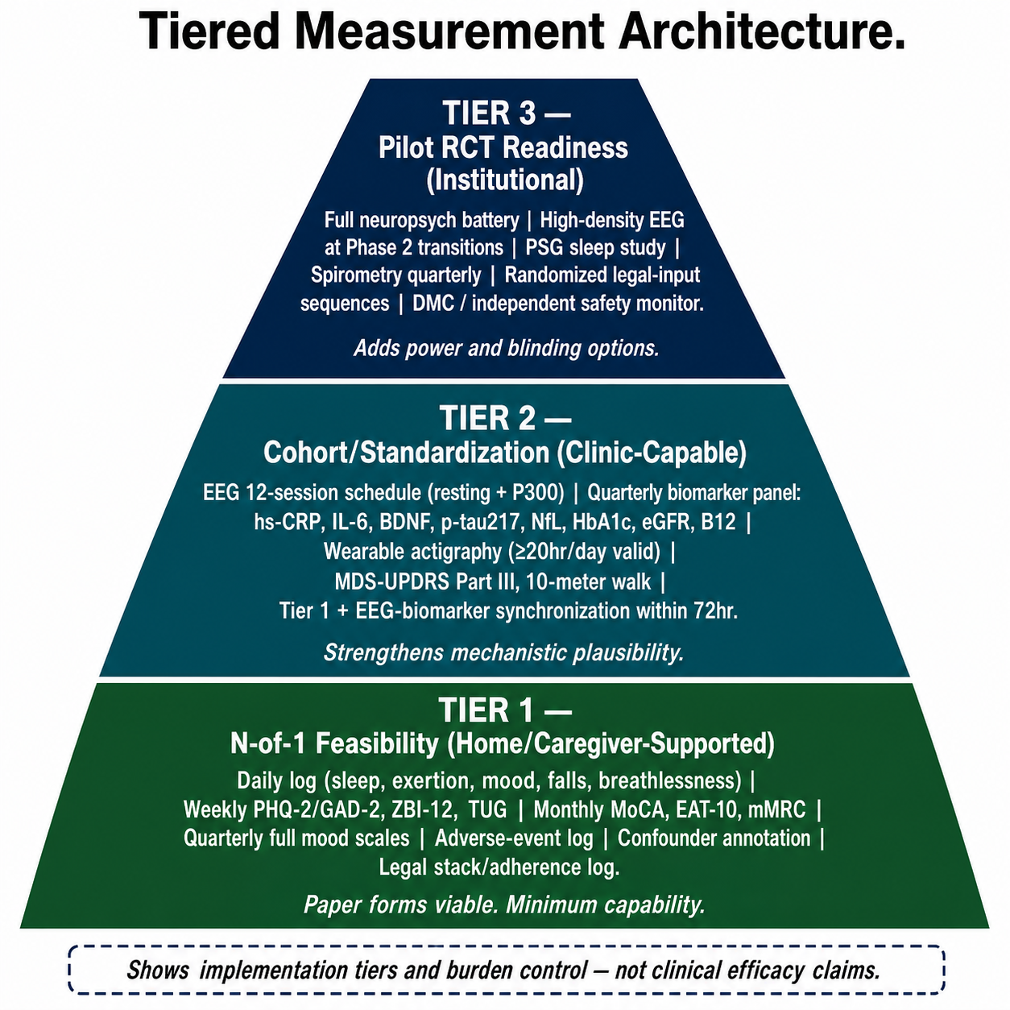
Figure 2. Tiered Measurement Architecture. Layered measurement pyramid distinguishing Tier 1 N-of-1 feasibility, Tier 2 clinic-capable standardization with EEG/biomarkers/wearables, and Tier 3 institutional pilot-RCT readiness. The figure describes implementation tiers and burden control only; it does not claim clinical efficacy.
Table 8. Revised tiered outcome framework.
Domain | Tier 1 mandatory | Tier 2 required/expanded | EEG relation | Biomarker relation
Cognition | Daily clarity/memory/attention 0-10; MoCA monthly where feasible. | Trail Making A/B; verbal fluency; delayed recall. | P300 amplitude/latency; alpha/theta ratio. | BDNF; p-tau217; NfL.
Mobility and falls | TUG weekly; daily falls/near-falls; standardized fall event form. | 10-meter walk; MDS-UPDRS Part III; PSP rating scale; video-standardized gait. | Beta corticomotor coherence; frontal-central connectivity. | Inflammatory markers as confounder context.
Mood/distress | Daily mood/distress 0-10; weekly PHQ-2/GAD-2 or PHQ-4; PHQ-9/GAD-7 quarterly. | Monthly PHQ-9/GAD-7 in Tier 2+. | P300 amplitude/latency; theta power. | IL-6; TNF-alpha; hs-CRP exploratory correlates.
Sleep/repair | Daily sleep hours and quality; PSQI quarterly. | Actigraphy/wearable sleep efficiency; sleep-device adherence where prescribed. | Prior-night sleep quality confounds all EEG sessions. | Sleep is an interpretive gate.
Respiratory | Daily breathlessness 0-10; SpO2 where available. | mMRC/CAT; spirometry; 6MWT. | Low oxygenation flagged as EEG/cognitive confounder. | Inflammatory markers as respiratory context.
Circadian/light | Wake time; bedtime; morning light yes/no; nap minutes; weekly CRI. | Actigraphy-derived regularity where available. | CRI tested against EEG alpha/theta ratio. | None primary.
Dysphagia | EAT-10 baseline, monthly, and as indicated. | Speech-language pathology referral data where clinically available. | Not EEG-linked. | Nutrition/adherence confounder.
Function | RAY-VASC Modified ADL/IADL v0.1; proxy mode recorded. | Lawton-Brody IADL; Katz ADL. | Not primary EEG-linked. | Adherence and caregiver context.
Caregiver burden | ZBI-12 alternate-week or weekly depending tier; caregiver flag retained. | Full burden battery where feasible. | Not EEG-linked. | Primary feasibility/safety context.
EEG/neuroplasticity | Tier 2 Required across all phases and both cycles when Tier 2 implemented. | Twelve-session schedule; connectivity at Phase 2 transition and closeout. | Primary EEG readout: delta/theta, alpha/beta, alpha/theta, P300, aperiodic exponent. | hs-CRP; IL-6; TNF-alpha; BDNF; p-tau217; NfL.
Biomarkers | Not Tier 1 mandatory. | Tier 2 Required quarterly, co-scheduled with EEG within 72 hours. | Correlated with EEG at matched timepoints. | hs-CRP; IL-6; TNF-alpha; BDNF; p-tau217; NfL; HbA1c; eGFR; homocysteine; B12; CBC.
Wearables | Not Tier 1 mandatory; passive capture preferred. | Valid day requires >=20 hours wear; CSV or structured export. | Sleep and oxygenation confound EEG. | Feasibility and confounder layer.
Legal stack adherence | Daily adherence log; standardized stack/legal input log. | Lot/batch; CoA; reviewer; response-policy version. | Stack changes create 14-day confounder window. | Adherent days vs biomarker trajectory.
EEG is Tier 2 Required across all phases and both cycles when a site implements Tier 2. EEG sessions use resting-state recording and P300 ERP to capture serial neurophysiology. The standard Tier 2 platform is the Bitbrain Diadem 12-channel dry-electrode portable EEG system or an analytically compatible system that documents channel layout, electrode type, sampling rate, export format, and preprocessing pipeline. Sites with institutional lab capacity may use higher-density systems at Phase 2 transition and closeout timepoints, provided the analysis pipeline remains compatible.
The Tier 2 biomarker panel is co-scheduled with EEG within a 72-hour window at quarterly timepoints. The core panel includes inflammatory markers (hs-CRP, IL-6, TNF-alpha), neuroplasticity/neurodegeneration markers (BDNF, p-tau217, NfL), and metabolic/vascular/safety markers (HbA1c, eGFR, homocysteine, B12, CBC). Sites must document laboratory, assay method, reference range, and maintain assay consistency across timepoints. Plasma pTau217 testing is commercially available through reference laboratories, but values from different methods cannot be used interchangeably; laboratory and assay method must remain consistent for within-subject interpretation.
Figure 4 details the EEG-biomarker synchronization rule and the EEG confounder-gate requirements used before directional EEG interpretation.
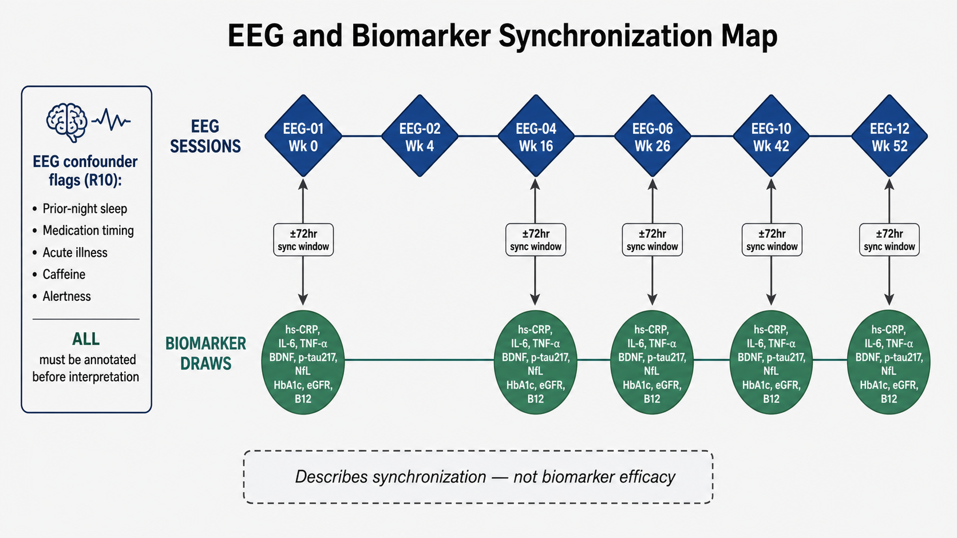
Figure 4. EEG and Biomarker Synchronization Map. Synchronization map showing selected EEG sessions, co-scheduled biomarker draws, 72-hour synchronization windows, and the required EEG confounder flags. The figure describes synchronization logic only and does not claim biomarker efficacy.
Table 9. Pre-specified EEG-biomarker correlation hypotheses.
EEG metric | Correlated biomarker | Expected direction | Interpretation boundary
Delta/theta power | hs-CRP, IL-6, TNF-alpha | Higher inflammation expected to align with higher slow-wave burden. | Exploratory; matched timepoints only.
Alpha/beta coherence | BDNF | Higher BDNF hypothesized to align with higher alpha/beta coherence. | Exploratory; no efficacy threshold.
Alpha/theta ratio | p-tau217 | Higher tau burden hypothesized to align with lower alpha/theta ratio. | Exploratory.
P300 amplitude | BDNF, NfL | Higher BDNF and lower NfL hypothesized to align with larger P300 amplitude. | Exploratory.
P300 latency | hs-CRP, eGFR | Higher inflammatory or renal stress may align with slower P300 latency. | Exploratory.
Aperiodic exponent | Neuroinflammatory composite | Steeper slope hypothesized to reflect higher disease/system burden. | Exploratory.
Theta/alpha ratio | Cognitive decline trajectory | Higher theta/alpha hypothesized to align with worse cognitive trajectory. | Exploratory.
Dysphagia is tracked because PSP-spectrum and vascular Parkinsonian phenotypes commonly involve swallowing risk, aspiration risk, nutrition risk, and oral-adherence confounding. EAT-10 is administered at baseline, monthly, and after any adverse event suggesting swallowing difficulty. EAT-10 score of 3 or higher triggers clinical referral and supplement/medication administration-route review. Route changes are logged as adherence-affecting protocol adaptations.
Falls are documented through daily fall/near-fall capture and a standardized Fall Event Form. A near-fall is operationally defined as a loss of balance requiring support, a wall, furniture, or another person to prevent ground contact. Post-injurious fall confounder windows are applied to motor/gait analysis.
The RAY-VASC Modified ADL/IADL v0.1 is an 11-item caregiver-proxy-capable instrument scored 0-22, with higher scores indicating greater independence. It is designed for frail neurovascular populations where standard IADL items may floor out. A change of at least 3 points is treated as clinically meaningful for surveillance, and a decline of at least 4 points within 4 weeks triggers clinical escalation review. ZBI-12 is included to quantify caregiver burden because caregiver sustainability is a direct feasibility and safety variable.
Table 10. RAY-VASC Modified ADL/IADL v0.1.
# | Domain | 0 - Dependent | 1 - Partially independent | 2 - Independent
1 | Mobility / ambulation | Cannot ambulate; bedbound or chair-bound. | Ambulates with physical assistance. | Ambulates independently with or without assistive device.
2 | Transfer | Cannot transfer without full physical lift. | Transfers with standby/minimal assist. | Transfers independently.
3 | Oral intake / swallowing | NPO/full tube feeding or unsafe oral intake. | Modified texture/thickened liquid or supervision. | Regular/soft diet and liquids without supervision.
4 | Medication administration | Full caregiver setup and administration. | Takes pre-organized meds with promptness. | Self-administers reliably.
5 | Communication | Cannot express basic needs reliably. | Expresses needs with effort/gesture/partial speech. | Communicates needs and simple information.
6 | Toileting / continence | Fully dependent. | Managed with schedule/prompt/products. | Manages independently.
7 | Dressing / basic self-care | Fully dependent. | Participates partially. | Independent with adaptive equipment if needed.
8 | Safety awareness | Cannot recognize hazards; continuous supervision. | Recognizes some hazards with reminders. | Consistently recognizes hazards and asks for help.
9 | Caregiver burden | High/critical burden; care is unsustainable. | Moderate burden; respite/support needed. | Manageable burden.
10 | Social engagement | No response/initiation. | Responds when others initiate. | Initiates/sustains familiar interaction.
11 | Structured activity | No structured activity. | >=1 structured activity/day with support. | >=2 structured activities with minimal prompt.
Interpretation bands for the Modified ADL/IADL are: 18-22 mildly dependent; 11-17 moderately dependent; 6-10 severely dependent; 0-5 profoundly dependent. Required confounder flags include acute infection within 7 days, medication change within 14 days, fall within 7 days, caregiver disruption, sleep collapse, and hospital/ER visit.
Because this is a feasibility and signal-detection protocol, PROs are not used to declare efficacy. Multiplicity is handled by domain separation, pre-specified feasibility endpoints, graphical reporting, and avoidance of confirmatory claims. Future powered trials must specify a single primary endpoint or a formal multiplicity strategy.

8. Participant timeline
The 52-week observation window is divided into two 26-week cycles. Cycle 1 establishes feasibility, baseline variability, and initial signal detection. Cycle 2 restarts Phase 1 with a fresh baseline window while treating Cycle 1 findings as prior hypotheses rather than established effects. If Phase 2 is unavailable, the protocol remains valid as a Phase 1 to Phase 3 observational execution across both cycles.
Figure 1 summarizes the 52-week participant timeline, phase windows, EEG sessions, biomarker synchronization points, and full assessment battery placements before the tabular Schedule of Events.
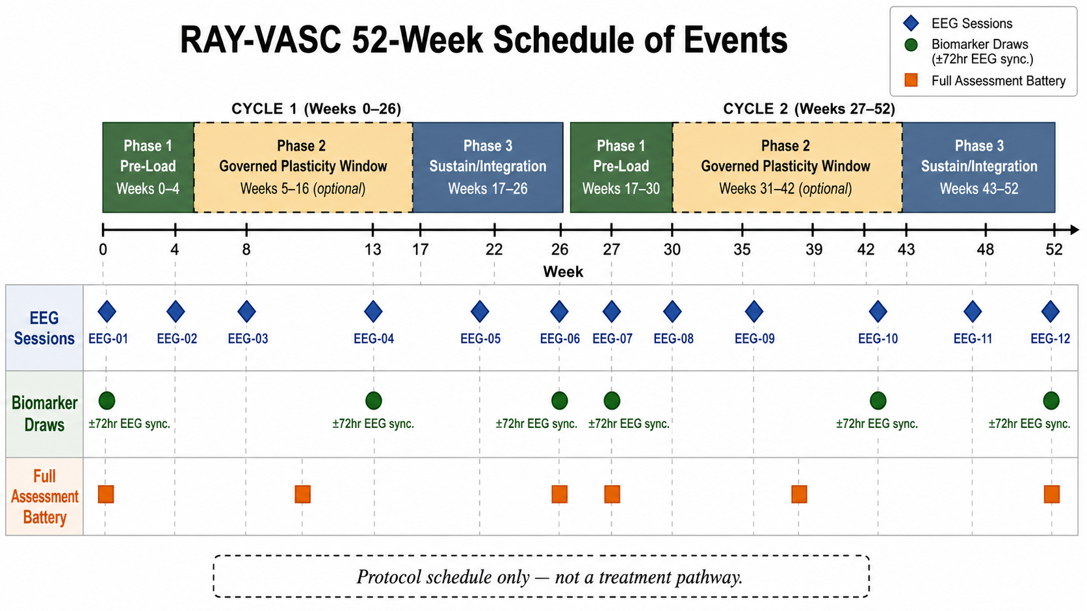
Figure 1. RAY-VASC 52-Week Schedule of Events. Two-cycle schedule-of-events diagram showing Phase 1 Baseline/Pre-Load, optional Phase 2 Governed Plasticity Window, Phase 3 Sustain/Integration, twelve EEG sessions, biomarker draw synchronization windows, and full assessment battery timepoints. The figure describes protocol timing only and does not define a treatment pathway.
Table 11. Condensed two-cycle Schedule of Events.
Visit / Timepoint | Week | Required procedures
Screening | -2 to 0 | Eligibility, site capability, consent/LAR, clinician oversight, medication review, safety baseline.
Cycle 1 baseline | 0-1 | Full baseline battery, EEG-01, Tier 2 biomarker panel, EAT-10, APPRE schema lock.
Cycle 1 Phase 1 | 1-4 | Daily Tier 1 log, weekly packet, circadian/light capture, legal stack log, AE/confounder review; EEG-02 at Week 4.
Cycle 1 Phase 2 if activated | 5-16 | Governance-specific safety log, daily/weekly capture, EEG-03 Week 8-9, EEG-04 Week 16, biomarker sync within 72 hours.
Cycle 1 Phase 3 | 17-26 | Sustain/integration; EEG-05 Week 22, EEG-06 Week 26, full domain battery and Tier 2 biomarkers.
Cycle 2 baseline | 27 | Fresh baseline window; full battery; EEG-07; compare to Week 0.
Cycle 2 Phase 1 | 27-30 | Daily/weekly capture, legal stack log, CRI, EEG-08 Week 30.
Cycle 2 Phase 2 if activated | 31-42 | Governance-specific safety log, EEG-09 Week 34-35, EEG-10 Week 42, biomarker sync.
Cycle 2 Phase 3 | 43-52 | Final sustain/integration; EEG-11 Week 48; EEG-12 Week 50-52; final domain battery and biomarkers.
Closeout | 52 | Data lock, AE/confounder audit, missingness summary, APPRE final response policy, repository package.
Table 12. Twelve-session EEG schedule.
EEG session | Week | Cycle/phase | Type | Primary scientific purpose
EEG-01 | 0-1 | Cycle 1 Phase 1 baseline | Resting + P300 | Reference values for band power, alpha/theta, P300, aperiodic exponent.
EEG-02 | 4 | Cycle 1 Phase 1 exit | Resting + P300 | Pre-load delta from legal stack and Regenerative Loop before any Phase 2 consideration.
EEG-03 | 8-9 | Cycle 1 Phase 2 mid, if activated | Resting + P300 | Early Phase 2 signal vs EEG-02.
EEG-04 | 16 | Cycle 1 Phase 2 exit, if activated | Resting + P300 + connectivity | Phase 2 neuroplasticity readout; biomarker sync.
EEG-05 | 22 | Cycle 1 Phase 3 mid | Resting + P300 | Durability check after Cycle 1 transition.
EEG-06 | 26 | Cycle 1 closeout | Resting + P300 + connectivity | Cycle 1 trajectory summary; biomarker sync.
EEG-07 | 27 | Cycle 2 baseline | Resting + P300 | Six-month longitudinal delta vs EEG-01.
EEG-08 | 30 | Cycle 2 Phase 1 exit | Resting + P300 | Cycle 2 pre-load effect vs EEG-07 and EEG-02.
EEG-09 | 34-35 | Cycle 2 Phase 2 mid, if activated | Resting + P300 | Second-cycle early Phase 2 signal.
EEG-10 | 42 | Cycle 2 Phase 2 exit, if activated | Resting + P300 + connectivity | Second-cycle full readout; compounding architecture hypothesis.
EEG-11 | 48 | Cycle 2 Phase 3 mid | Resting + P300 | Durability of Cycle 2 trajectory.
EEG-12 | 50-52 | Final closeout | Resting + P300 + connectivity + full-band summary | Complete 52-week longitudinal EEG trajectory; final biomarker sync.
The full twelve-session EEG schedule is the standard Tier 2 target. When site resources cannot support all sessions, minimum Tier 2 deviation-supported coverage consists of EEG-01, EEG-02, EEG-06, EEG-07, and EEG-12. Deviation-supported coverage must be documented as missingness/deviation, not treated as the full protocol target.

9. Data capture, APPRE, and data management
Acceptable data capture modes include paper forms with later double-entry, secure spreadsheet, REDCap, ePRO platform, custom schema implementation, or hybrid paper-to-digital workflow. Tier 1 must remain usable on paper. Data must be stored in access-controlled systems. Public repository files may include protocol documents, forms, schemas, synthetic examples, code, and de-identified templates only.
Figure 3 maps the daily, weekly, monthly, and quarterly capture cadence across core measurement domains so implementation teams can preserve burden limits while maintaining analytic coverage.
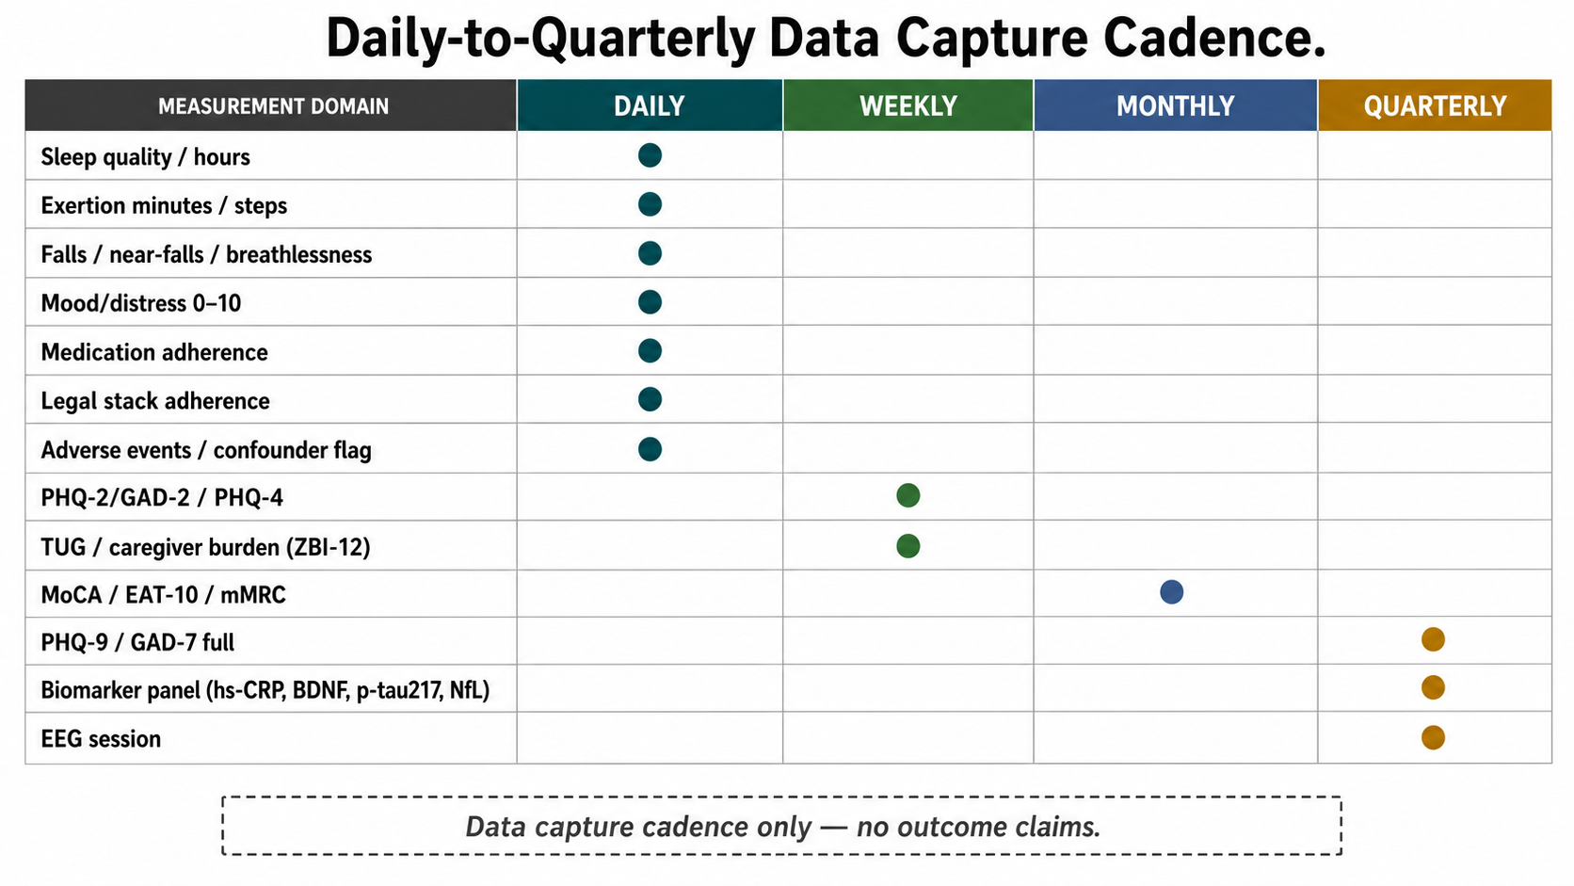
Figure 3. Daily-to-Quarterly Data Capture Cadence. Frequency matrix mapping measurement domains to daily, weekly, monthly, and quarterly capture intervals. The figure describes data capture cadence only and makes no outcome claim.
Wearable devices are Tier 2 Recommended. Acceptable device classes include consumer-grade wrist wearables with step count, heart rate, sleep duration, and SpO2, where available, and medical-grade ambulatory devices in Tier 3. A valid wearable day requires at least 20 hours of device wear. Wearable-day completeness is tracked as a feasibility metric alongside Tier 1 daily log completion. Data must be exportable in CSV or another structured format. When wearable-derived sleep and self-reported sleep quality diverge by more than one standard deviation from baseline, self-report is treated as primary, and the discordance is annotated as a data-quality item.
APPRE is implemented as a transparent schema-and-rules layer: Subject Profile -> Inputs -> Outcomes -> Updated Response Policy. APPRE is not validated artificial intelligence, not clinical decision support, and not a medical device in this manuscript. APPRE produces versioned response-policy documentation; it does not diagnose, prescribe, or replace clinician judgment.
Table 13. APPRE schema layer summary.
Layer | Fields / content
Subject Profile | subject_id; age_band; sex; diagnosis_category; phenotype_tags; baseline_moca; baseline_function_score; caregiver_available; setting_type; medication_list_hash; major_safety_flags; renal/hepatic status; falls risk; dysphagia status; respiratory status; sleep status; tier_level; consent_type.
Daily Input Log | date; phase; entry_by; sleep_hours; sleep_quality_0_10; wake_time_hhmm; bedtime_hhmm; morning_light_yn; nap_minutes; exertion_minutes; fall_count; near_fall_count; breathlessness_0_10; fatigue_0_10; mood_distress_0_10; medication_adherence; legal_input_adherence; sleep_treatment_adherence; social_contact; adverse_event_present; confounder_flag.
Weekly Assessment | week_number; phq2_total; gad2_total; phq4_total where used; zbi12_total; modified_adl_iadl_total_or_estimated; tug_seconds; falls_week; near_falls_week; adherence_percent; caregiver_burden_flag; ae_count; confounder_summary; CRI_minutes; cycle_interpretable.
Monthly/Quarterly Assessment | timepoint; moca_total; phq9_total; gad7_total; psqi_total; EAT10_total; mMRC/CAT; ten_meter_walk_seconds; biomarker_panel_complete; eeg_session_id; eeg_confounder_flags_complete; response_policy_version; interpretation_status.
Table 14. APPRE v1.8 rules R1-R13.
Rule | Name | Operational meaning
R1 | Safety override | Any severe or serious adverse event pauses response-policy progression until clinician review.
R2 | One-variable rule | Legal-input changes alter one primary variable at a time where feasible.
R3 | Baseline rule | No directional signal is interpreted without a baseline variability estimate.
R4 | Confounder rule | Infection, medication change, hospitalization, fall injury, sleep collapse, travel, or caregiver disruption must be annotated before interpretation.
R5 | Minimum adherence rule | Cycles with <70% Tier 1 completion are not primary-interpretable.
R6 | Signal threshold rule | Candidate signal requires >=0.3 SD directional change sustained across >=2 interpretable cycles.
R7 | Controlled-substance boundary | APPRE does not recommend, adjust, or optimize controlled-substance exposure outside formal governance.
R8 | Burden ceiling | Participant/caregiver burden triggers simplification before data ambition.
R9 | Versioned response policy | Every update includes date, reason, data window, rule activated, reviewer, and prior policy link.
R10 | EEG confounder gate | No EEG session is interpreted as directional signal until all five EEG confounder flags are annotated. Unresolved sessions are archived raw and excluded from primary EEG trajectory interpretation.
R11 | Cycle boundary rule | Cycle 2 Phase 1 generates a fresh baseline variability estimate. Cycle 1 findings become prior hypotheses, not established baselines.
R12 | Biomarker-EEG synchrony rule | Quarterly EEG sessions and biomarker draws must occur within 72 hours. Misaligned timepoints are excluded from primary EEG-biomarker correlation analysis.
R13 | Stack change rule | Any legal stack addition, removal, or dose change triggers a response-policy version increment, a two-week single-variable isolation window, and a 14-day confounder annotation.
Each response-policy update includes policy version, date, subject ID, phase, data window, interpretable-cycle status, safety events, confounder status, primary-domain trend, secondary-domain trend, activated rules, legal-input change if any, behavioral measurement change if any, burden adjustment if any, clinician review requirement, next review date, and reviewer.

10. Statistical analysis plan
Analysis populations include the enrolled population, safety population, feasibility population, interpretable-cycle population, and small-series population. For a single N-of-1 implementation, formal sample-size calculation for efficacy is not applicable because the primary objective is feasibility and measurement reliability. For small-series implementation, initial target enrollment is 3-10 participants to estimate protocol burden, missingness, adverse-event capture, and variance components.
Feasibility outcomes will be summarized descriptively using proportions, medians, ranges, missingness by domain/timepoint, and proxy/self-completion mode distribution. Directional signal will be analyzed within participant by plotting time-series trajectories, marking phase boundaries, overlaying adverse events and confounders, estimating baseline mean and standard deviation, calculating change from baseline for each cycle, flagging >=0.3 SD changes sustained across at least two interpretable cycles, and avoiding efficacy claims.
EEG spectral trajectory analysis will plot resting-state band power (delta, theta, alpha, beta) across all twelve EEG sessions on a single session-number axis, with phase boundary markers, adverse-event overlays, and confounder-period shading. The alpha/theta ratio will be tracked as a composite neurophysiology index across sessions. At quarterly timepoints where EEG and biomarker draws occur within 72 hours, scatter plots will display alpha/theta ratio versus hs-CRP and IL-6, and P300 amplitude versus BDNF. These are exploratory analyses; no statistical thresholds for efficacy or clinical significance are asserted.
Lagged analyses will test the three pre-specified exploratory hypotheses only. Additional lagged associations may be reported as exploratory discovery analyses if clearly labeled. Missing data are not imputed as improvement or deterioration. Cycles below the interpretability threshold are excluded from primary signal interpretation but retained in raw archives. Sensitivity analyses may exclude infection weeks, medication-change windows, post-fall windows, caregiver-change windows, low-adherence cycles, and EEG sessions with unresolved confounder flags.
Visualization conventions are standardized for reproducibility. Primary domain trajectory plots use week number on the x-axis, raw or SD-normalized domain score on the y-axis, vertical phase boundary lines, red triangles for adverse events, gray bands for confounder windows, blue diamonds for EEG sessions, and green circles for biomarker draws. All published plots must be reproducible from a public Python or R notebook. No proprietary or unshared pipeline is acceptable for primary figures.
Figure 7 defines the confounder annotation flow used to prevent overinterpretation of candidate signal during primary directional analysis.
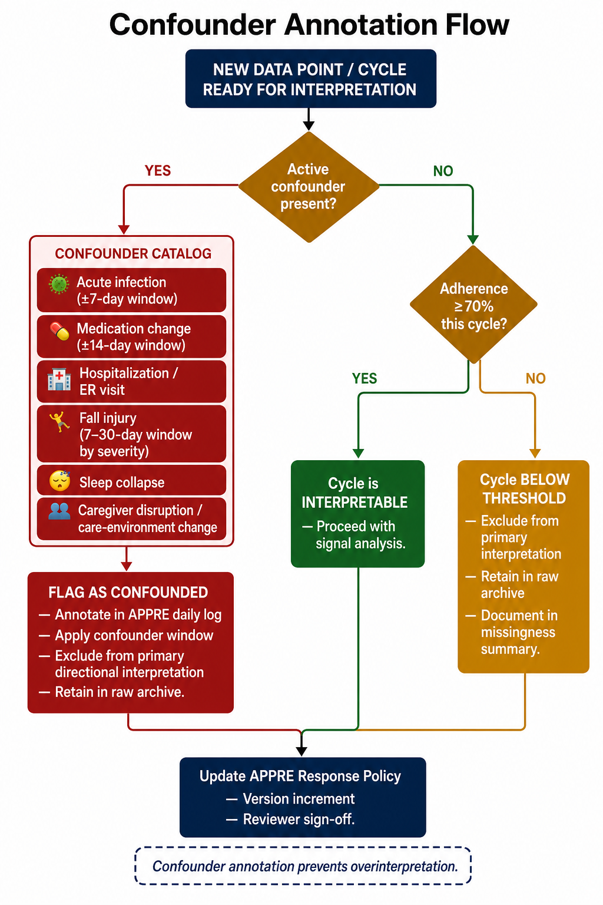
Figure 7. Confounder Annotation Flow. Decision tree for identifying active confounders, applying pre-specified confounder windows, determining cycle interpretability, and updating the APPRE response policy. The figure is designed to prevent overinterpretation by separating raw archive retention from primary directional interpretation.

11. Safety monitoring, ethics, and governance
Any external prospective implementation intended to contribute to generalizable knowledge requires IRB review, ethics review, or formal determination before enrollment. OSF registration is required before external prospective data collection. Participants with capacity provide written informed consent. Participants with impaired decisional capacity may participate only where LAR/proxy consent is valid, and participant assent is obtained where feasible. Separate ancillary consent is required for public case attribution, identifiable clinical details, genetic testing, EEG data sharing, biomarker sharing, imaging sharing, audio/video capture, future unspecified research use, and repository contribution beyond de-identified protocol data.
Figure 6 operationalizes the safety-monitoring workflow: safety triggers move through severity triage, protocol burden adjustment, clinician escalation, APPRE response-policy update, and continue-or-terminate decisions.
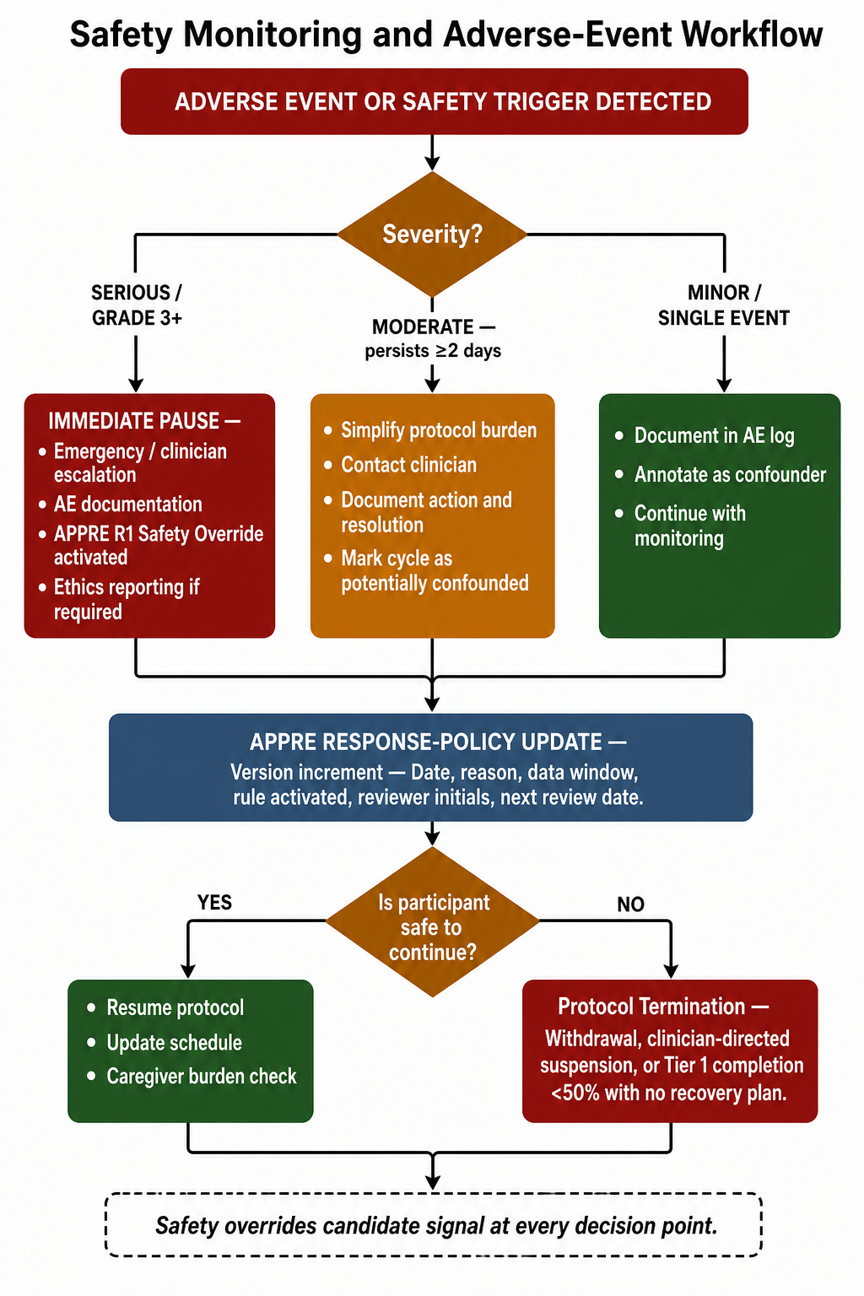
Figure 6. Safety Monitoring and Adverse-Event Workflow. Safety workflow from adverse-event or safety-trigger detection through severity triage, immediate pause or monitoring actions, APPRE response-policy update, and continuation/termination decision. Safety overrides candidate signal at every decision point.
Table 15. Safety actions and stopping rules.
Trigger | Action
New stroke/TIA-like symptoms, chest pain, severe shortness of breath, fainting, severe confusion, psychosis/mania/suicidal crisis, injurious fall, serious bleeding/bruising, severe allergic reaction, severe GI distress with dehydration risk, sustained oxygenation concern, aspiration event, or any serious adverse event. | Immediate pause, emergency or clinician escalation, adverse-event documentation, APPRE R1 safety override, and ethics reporting where required.
Moderate adverse event persisting for two or more consecutive days. | Simplify protocol burden, contact clinician, document action/resolution, and mark cycle as potentially confounded.
Caregiver burden becomes severe or care sustainability is threatened. | Reduce measurement burden, trigger support review, and mark cycle as burden-confounded where appropriate.
Major unannotated medication change, infection, hospitalization, fall injury, sleep collapse, travel, or caregiver disruption. | Flag as confounded; exclude from primary directional interpretation until stable and annotated.
EAT-10 score >=3, suspected aspiration, or aspiration pneumonia concern. | Clinical referral and route-modification review; suspected aspiration triggers protocol pause pending clinical evaluation.
eGFR decline >20% from baseline or eGFR <45 mL/min/1.73 m2. | Review renally relevant legal inputs, trigger APPRE safety override, and document clinician review.
Table 16. Fall-event definitions and confounder windows.
Event / severity | Protocol handling
Near-fall definition | Loss of balance requiring support, wall, furniture, or another person to prevent ground contact.
No injury/minor event | Complete Fall Event Form; apply 7-day motor/gait confounder window.
Minor injury requiring functional adaptation | Complete Fall Event Form; apply 14-day motor/gait confounder window and clinician review as needed.
Moderate/major injury | Complete Fall Event Form; apply 30-day window or until clinical clearance; exclude from primary TUG/gait trajectory.
A formal independent Data Monitoring Committee is not required for the minimum viable Tier 1 observational N-of-1 protocol because there is no randomized allocation, no investigational drug assignment by the protocol, and no blinded interventional arm. A DMC or independent safety monitor should be added for multi-site implementation, higher-risk exposure environments, or any interventional trial version.
Post-trial clinical care remains with the participant’s existing clinicians. Any harm compensation, insurance, or injury coverage is determined by the implementing site, sponsor, or institutional policy and must be stated in consent documents. For self-funded independent implementations, participants must be informed if no research-specific injury compensation mechanism exists.

12. Open science, reproducibility, and repository governance
OSF preregistration precedes external prospective participant data collection. The OSF record should include protocol version, study design, eligibility criteria, outcomes, Schedule of Events, APPRE schema, analysis plan, safety plan, data-sharing statement, privacy boundary, and amendments process. Public data sharing includes protocol documents, forms, schemas, synthetic datasets, analysis notebooks, data dictionaries, and evidence maps. Individual-level clinical data are not shared publicly without separate consent, privacy review, and de-identification.
The RAY-VASC repository maintains the current approved protocol version on the main branch. All protocol amendments generate a new version tag with a CHANGELOG.md entry documenting what changed, why, the evidence or data window triggering the change, whether the OSF preregistration record was updated, and which forms/schemas/analysis files were affected. Supplementary appendices, Schedule of Events CSV, APPRE schema JSON, form PDFs, and data dictionary files are versioned alongside the main manuscript using matching tags. Protocol deviations are documented in the deviation log and are not silently corrected in the repository.
Before enrollment, implementing teams must lock the protocol version, complete OSF registration, document site capability, approve consent forms, finalize daily/weekly forms, finalize APPRE schema, finalize adverse-event and confounder logs, secure data storage, confirm clinician escalation pathway, train caregiver/proxy personnel, and schedule baseline assessment.

13. Discussion
RAY-VASC provides a structured protocol for measuring complex neurovascular disease as a coupled biological and operational system. It does not attempt to prove treatment efficacy in its first version. Its contribution is the infrastructure required before efficacy claims can be responsibly tested: eligibility gates, burden ceilings, caregiver/proxy workflow, adverse-event capture, confounder annotation, serial EEG, synchronized biomarker collection, stack/legal input documentation, and reproducible analysis conventions.
The major correction retained in this final release is the elevation of EEG from a loosely described exploratory measure to a Tier 2 Required longitudinal measure across all phases and both cycles when Tier 2 is implemented. This matters because the protocol’s central neuroplasticity hypothesis requires an objective neurophysiology trajectory. EEG-02 at Week 4 is especially important because it captures the baseline-to-pre-load delta before any Phase 2 consideration. Without that measurement, the protocol cannot separate Phase 1 substrate effects from later exposure-window effects.
The biomarker-EEG synchronization rule strengthens the protocol by forcing clinical function, neurophysiology, and inflammatory/neurodegenerative markers into the same analytical window. A convergent directional pattern across MoCA/TUG/function, EEG alpha/theta/P300, and hs-CRP/IL-6/BDNF/p-tau217 would not prove efficacy. It would, however, create a stronger hypothesis-generating signal than any single stream alone. Conversely, discordant streams would refine the model by showing where the hypothesized cascade does not hold.
The protocol is deliberately modular. Tier 1 remains viable for frail participants and caregiver-supported settings. Tier 2 adds EEG, biomarkers, wearables, and EAT-10 as required or standardized layers where capability exists. Tier 3 prepares institutional, biomarker-enriched, or randomized designs. The design principle is simple: learn the minimum layer flawlessly, then add higher-resolution layers only where the foundation is stable.
Figure 8 summarizes how the N-of-1 design can expand into a small-series pathway while preserving individual heterogeneity and avoiding pooled-effect claims.
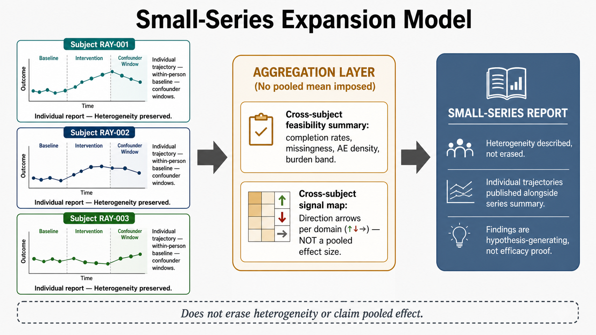
Figure 8. Small-Series Expansion Model. Small-series aggregation model in which individual N-of-1 trajectories retain within-person baselines and confounder windows before contributing to cross-subject feasibility summaries and directional signal maps. The model does not erase heterogeneity or claim a pooled effect.

14. Limitations and future directions
1. This protocol is hypothesis-generating and reports no human-subject outcomes.
2. Observational N-of-1 implementation cannot establish causality and limits generalizability.
3. Multicomponent exposure environments limit attribution.
4. Legal candidate inputs may have batch, formulation, and certificate-of-analysis variability.
5. PROs may be affected by proxy bias, caregiver mood, fatigue, expectancy, and mode shifts.
6. Cognitive testing may show practice effects.
7. Wearable data quality may vary across devices and adherence patterns.
8. Biomarker and EEG access may vary across sites.
9. EEG equipment heterogeneity introduces cross-site reliability risk; sites using non-standard hardware must document channel layout, electrode type, sampling rate, export format, and preprocessing pipeline.
10. P300 amplitude and latency are affected by medication class, sleep quality, anxiety level, alertness, fatigue, caffeine timing, and acute illness; all five EEG confounder flags must be co-logged with every EEG session.
11. Optional Phase 2 governance may not be available at many sites; Phase 2 non-activation does not invalidate the Tier 1 or Tier 2 observational objectives.
12. APPRE is not a validated AI and must not be marketed as clinical decision support.
13. Natural-history comparisons are exploratory only.
The minimum viable study is one participant, 52 weeks, two-cycle observation, 14-28 day baseline window, daily Tier 1 log, weekly PHQ-2/GAD-2 or PHQ-4, caregiver burden capture, modified ADL/IADL, TUG, falls, adverse-event and confounder review, monthly MoCA/respiratory/dysphagia review, quarterly full mood scales, OSF registration, de-identified dataset, analysis notebook, safety log, and protocol-deviation log. The Scale-to-RCT pathway is N-of-1 feasibility, 3-10 participant small series, multi-site observational registry, legal-input standardization study, biomarker/EEG-enriched mechanistic pilot, randomized feasibility trial, controlled pragmatic trial, domain-specific RCT, and CONSORT/CONSORT-CENT results reporting.

15. Conclusion
RAY-VASC is a protocol for disciplined measurement before claims. It converts the Regenerative Loop, APPRE, serial EEG, synchronized biomarkers, caregiver-supported reporting, and two-cycle Compounding Plasticity Architecture into an externally implementable research design for complex neurovascular disease. The protocol is hypothesis-generating, safety-gated, open-source, and built for qualified teams to test, replicate, critique, and improve.
The manuscript does not claim treatment efficacy, disease modification, brain repair, vascular lesion reversal, PSP reversal, dementia reversal, or recovery guarantees. Its value is operational: it defines what must be measured, how confounders must be tracked, how proxy data are handled, how EEG and biomarkers are synchronized, how legal inputs are documented, and how future studies can move from N-of-1 feasibility toward stronger designs.

Data availability statement
Figure accessibility statement: Figures are embedded in the manuscript body with descriptive captions and alternative-text descriptions. High-resolution figure assets are included in the public repository and OSF package as separate PNG files for accessibility review, reuse, and journal production workflows.
No new clinical data are reported in this protocol manuscript. Protocols, forms, schemas, evidence maps, synthetic examples, and analysis pipeline templates are intended for public release through the RAY-VASC repository and OSF registration record. Individual-level clinical data will not be made public without separate consent, privacy review, de-identification, and ethics governance.

Ethics statement
This manuscript reports protocol architecture and does not report human-subject outcomes. Any future implementation involving identifiable participants, prospective data collection, clinical intervention, controlled-substance exposure, imaging, EEG, biomarkers, or data sharing requires appropriate consent, privacy review, clinician oversight, and IRB or ethics review as applicable.

Conflict of interest statement
The originating researcher reports no product line, supplement brand, retreat, clinic, or treatment service associated with this manuscript. The public RAY-VASC repository is a publication-only research infrastructure. Any future commercial, institutional, or funding relationship would require separate disclosure before submission or publication.

Funding
This protocol manuscript received no external funding.

Author contributions
Logan Henderson conceived the framework, developed the RAY-VASC protocol architecture, designed the APPRE schema-and-rules layer, integrated the Regenerative Loop and Compounding Plasticity Architecture, specified the open-source protocol structure, and wrote the manuscript.

Acknowledgments
This framework was motivated by the care of Raymond Hornsby, who is acknowledged as the human origin point of the RAY-VASC research program, where authorization permits public attribution. Christine A. Hood is acknowledged for family authorization and care coordination support. No raw medical records or individual-level clinical outcomes are reported in this manuscript.

Disclaimer
Not medical advice. Not legal advice. This manuscript is for research planning, documentation, and protocol/measurement design only. It is not clinical care, a treatment recommendation, a supplement protocol, or a controlled-substance protocol. All clinical decisions remain clinician-directed. Controlled-substance exposure, if any, requires lawful jurisdiction, ethics governance, qualified clinical oversight, informed consent, and adverse-event monitoring.

References
Bédard, M., Molloy, D. W., Squire, L., Dubois, S., Lever, J. A., & O'Donnell, M. (2001). The Zarit Burden Interview: A new short version and screening version. The Gerontologist, 41(5), 652-657. https://doi.org/10.1093/geront/41.5.652
Belafsky, P. C., Mouadeb, D. A., Rees, C. J., Pryor, J. C., Postma, G. N., Allen, J., & Leonard, R. J. (2008). Validity and reliability of the Eating Assessment Tool (EAT-10). Annals of Otology, Rhinology & Laryngology, 117(12), 919-924. https://doi.org/10.1177/000348940811701210
Bitbrain. (n.d.). Diadem: Portable dry-electrode EEG system. Bitbrain Technologies. https://www.bitbrain.com/products/dry-eeg/diadem
Blest-Hopley, G., Pasculli, G., Ruffell, S. G. D., Tsang, W., Emmanuel, O., Pate, K. M., Kettner, H., Roseman, L., Erritzoe, D., & Carhart-Harris, R. (2025). Improved mental health outcomes and normalised spontaneous EEG activity in veterans reporting a history of traumatic brain injuries following participation in a psilocybin retreat. Frontiers in Psychiatry, 16, 1594307. https://doi.org/10.3389/fpsyt.2025.1594307
Buysse, D. J., Reynolds, C. F., Monk, T. H., Berman, S. R., & Kupfer, D. J. (1989). The Pittsburgh Sleep Quality Index: A new instrument for psychiatric practice and research. Psychiatry Research, 28(2), 193-213. https://doi.org/10.1016/0165-1781(89)90047-4
Calvert, M., Kyte, D., Mercieca-Bebber, R., Slade, A., Chan, A.-W., King, M. T., Hunn, A., Bottomley, A., Regnault, A., & International Society for Quality of Life Research. (2018). Guidelines for inclusion of patient-reported outcomes in clinical trial protocols: The SPIRIT-PRO extension. JAMA, 319(5), 483-494. https://doi.org/10.1001/jama.2017.21903
Chan, A.-W., Boutron, I., Hopewell, S., Moher, D., Schulz, K. F., Collins, G. S., et al. (2025). SPIRIT 2025 statement: Updated guideline for protocols of randomised trials. BMJ, 389, e081477. https://doi.org/10.1136/bmj-2024-081477
Davis, A. K., Barrett, F. S., May, D. G., et al. (2021). Effects of psilocybin-assisted therapy on major depressive disorder: A randomized clinical trial. JAMA Psychiatry, 78(5), 481-489. https://doi.org/10.1001/jamapsychiatry.2020.3285
Food and Drug Administration. (2025, May 16). FDA clears first blood test used in diagnosing Alzheimer's disease. https://www.fda.gov/news-events/press-announcements/fda-clears-first-blood-test-used-diagnosing-alzheimers-disease
Goodwin, G. M., Aaronson, S. T., Alvarez, O., et al. (2022). Single-dose psilocybin for a treatment-resistant episode of major depression. New England Journal of Medicine, 387, 1637-1648. https://doi.org/10.1056/NEJMoa2206443
Goetz, C. G., Tilley, B. C., Shaftman, S. R., et al. (2008). Movement Disorder Society-sponsored revision of the Unified Parkinson's Disease Rating Scale (MDS-UPDRS): Scale presentation and clinimetric testing results. Movement Disorders, 23(15), 2129-2170. https://doi.org/10.1002/mds.22340
Henderson, L. (2026). The Brain That Remains: A framework for neuroplasticity, residual capacity, and open-source protocol design in complex neurodegenerative disease. RAY-VASC Regenerative Loop repository.
Hopewell, S., Chan, A.-W., Collins, G. S., Hróbjartsson, A., Moher, D., Schulz, K. F., Terwee, C. B., Vohra, S., & Elbourne, D. R. (2025). CONSORT 2025 statement: Updated guideline for reporting randomised trials. BMJ, 388, e081123. https://doi.org/10.1136/bmj-2024-081123
Kongkeaw, C., Dilokthornsakul, P., Thanarangsarit, P., Limpeanchob, N., & Scholfield, C. N. (2014). Meta-analysis of randomized controlled trials on cognitive effects of Bacopa monnieri extract. Journal of Ethnopharmacology, 151(1), 528-535. https://doi.org/10.1016/j.jep.2013.11.008
Kravitz, R. L., Duan, N., & Braslow, J. (2004). Evidence-based medicine, heterogeneity of treatment effects, and the trouble with averages. Milbank Quarterly, 82(4), 661-687. https://doi.org/10.1111/j.0887-378X.2004.00327.x
Kroenke, K., Spitzer, R. L., & Williams, J. B. W. (2001). The PHQ-9: Validity of a brief depression severity measure. Journal of General Internal Medicine, 16(9), 606-613. https://doi.org/10.1046/j.1525-1497.2001.016009606.x
Kroenke, K., Spitzer, R. L., Williams, J. B. W., & Löwe, B. (2009). An ultra-brief patient-reported measure of anxiety and depression: The PHQ-4. Psychosomatics, 50(6), 613-621. https://doi.org/10.1176/appi.psy.50.6.613
Labcorp. (2026). Phosphorylated Tau 217 (pTau-217), Plasma: Test number 484390. https://www.labcorp.com/tests/484390/phosphorylated-tau-217-ptau-217-plasma
Lawton, M. P., & Brody, E. M. (1969). Assessment of older people: Self-maintaining and instrumental activities of daily living. The Gerontologist, 9(3), 179-186. https://doi.org/10.1093/geront/9.3_Part_1.179
Nasreddine, Z. S., Phillips, N. A., Bédirian, V., et al. (2005). The Montreal Cognitive Assessment, MoCA: A brief screening tool for mild cognitive impairment. Journal of the American Geriatrics Society, 53(4), 695-699. https://doi.org/10.1111/j.1532-5415.2005.53221.x
Ngandu, T., Lehtisalo, J., Solomon, A., et al. (2015). A two year multidomain intervention of diet, exercise, cognitive training, and vascular-risk monitoring versus control to prevent cognitive decline in at-risk elderly people (FINGER): A randomised controlled trial. The Lancet, 385(9984), 2255-2263. https://doi.org/10.1016/S0140-6736(15)60461-5
Podsiadlo, D., & Richardson, S. (1991). The timed Up and Go: A test of basic functional mobility for frail elderly persons. Journal of the American Geriatrics Society, 39(2), 142-148. https://doi.org/10.1111/j.1532-5415.1991.tb01616.x
Porcino, A. J., Shamseer, L., Chan, A.-W., Kravitz, R. L., Orkin, A., Punja, S., Ravaud, P., Schmid, C. H., & Vohra, S. (2020). SPIRIT extension and elaboration for N-of-1 trials: SPENT 2019 checklist. BMJ, 368, m122. https://doi.org/10.1136/bmj.m122
Quest Diagnostics. (2025, July 9). Quest Diagnostics to offer FDA-cleared Fujirebio blood test for Alzheimer's disease. https://newsroom.questdiagnostics.com/2025-07-09-Quest-Diagnostics-to-Offer-FDA-Cleared-Fujirebio-Blood-Test-for-Alzheimers-Disease
Rosenberg, A., Mangialasche, F., Ngandu, T., Solomon, A., & Kivipelto, M. (2020). Multidomain interventions to prevent cognitive impairment, Alzheimer's disease, and dementia: From FINGER to World-Wide FINGERS. Journal of Prevention of Alzheimer's Disease, 7(1), 29-36. https://doi.org/10.14283/jpad.2019.41
Shamseer, L., Sampson, M., Bukutu, C., et al. (2015). CONSORT extension for reporting N-of-1 trials (CENT) 2015: Explanation and elaboration. BMJ, 350, h1793. https://doi.org/10.1136/bmj.h1793
Spitzer, R. L., Kroenke, K., Williams, J. B. W., & Löwe, B. (2006). A brief measure for assessing generalized anxiety disorder: The GAD-7. Archives of Internal Medicine, 166(10), 1092-1097. https://doi.org/10.1001/archinte.166.10.1092
Vohra, S., Shamseer, L., Sampson, M., et al. (2015). CONSORT extension for reporting N-of-1 trials (CENT) 2015 statement. BMJ, 350, h1738. https://doi.org/10.1136/bmj.h1738
Zarit, S. H., & Zarit, J. M. (1987). The memory and behavior problems checklist and the burden interview. Pennsylvania State University Gerontology Center.

